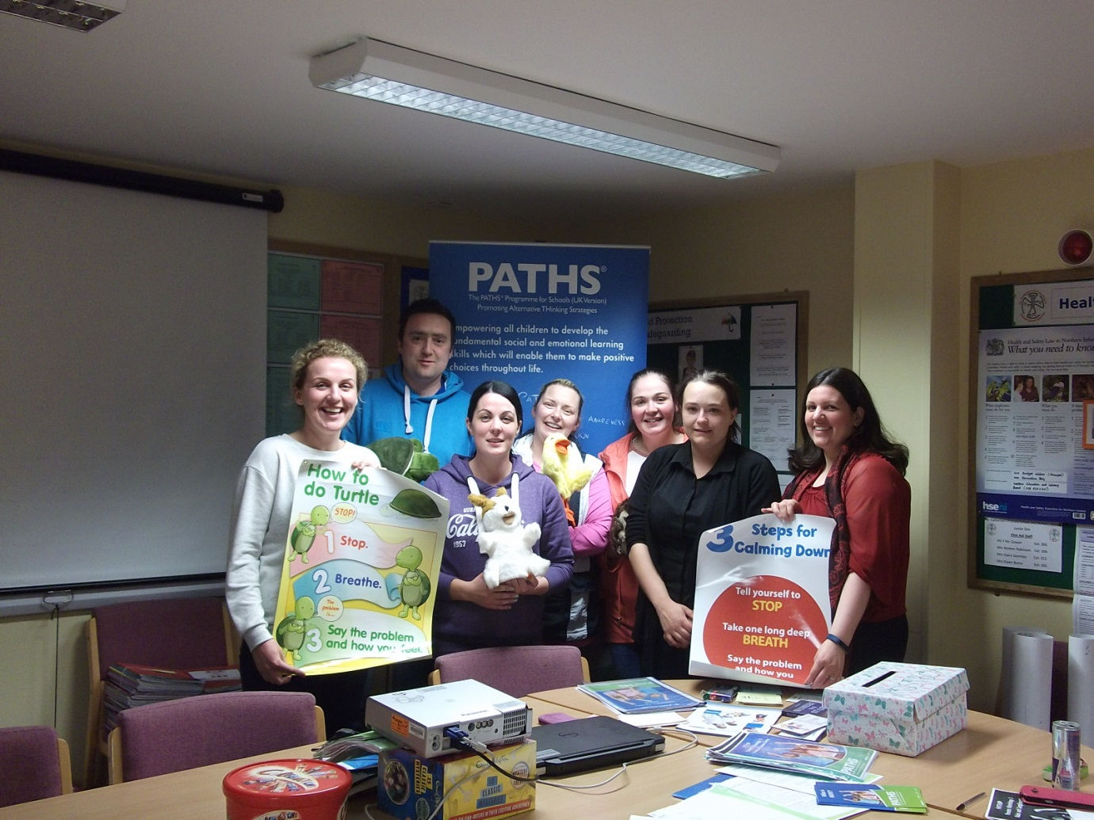
Our fantastic PATHS parents with our PATHS coach Mrs Lindsay McSparron

